**MEETING MINUTES: SUMO DIGITAL GROUP PROJECT**

**Date of meeting:** 13/03/2019

**Time of meetin**g: 10:20 AM

**Attendees**: Dragos Liche, Dawid Hojka and Alex Butler

**Apologies from:** Anthony Skipwith **(Discord screenshot #16)**

**Post-mortem of previous week:**

**What went well:** Most of the tasks were completed over the duration of the week. The overall aim of the last week is to get all assets into the game so that this week we can work on implementing them and ready the game for playtesting and we have almost achieved that, so we will have to put in a bit more work this week so that we can playtest as planned. Anthony also cleaned up the GitHub repository from the excess folders, so it’s back to being organised.

**What went badly**: Due to JIRA not working for the duration of this morning, it’s hard to determine whether the tasks were logged or not, and similarly we can’t end the sprint and start a new one, meaning this will have to be done at a later date. However, Dragos typed the tasks in the Discord **(Discord screenshot #17)**, so we can add them whenever JIRA is back on. In terms of unfinished tasks Anthony wasn’t able to finish implementing enemy projectiles/attacks and Alex still has the slot machine to finish.

**Feedback received**: During the duration of the week, we did receive some feedback from the presentation that happened last week. We were told that the overall game idea implies that over the duration the game will become more chaotic, something similar to a bar fight, with flying/ragdolling chairs and tables, and our current game does not reflect that very well, if at all.

We have discussed amongst ourselves, that we should indeed focus on that idea of the increasing chaos, as we think it would help us achieve the emotions we are aiming to receive from players, like surprise, fiero and some humour.

**Individual work completed:-**

* **Dragos:** Expanded upon the bar area, as well as completed the lamp, as a rocket launcher, weapon asset.
* **Dawid:** Animated the fall/death animations for the characters.
* **Anthony:** Added better collision to the level, so that objects within could be ragdolled. He also fixed the GitHub main repository.
* **Alex:** Completed the sink and toiler 3D assets. Has started the 3D model for the slot machine asset.

**Overall aim of the current week’s sprint**

The overall aim of this week is to start implementing the mechanics that would contribute to the chaos element of the game, through visual feedback (ragdolling, particle effects), alongside continuous development of the bar level, through further expansion and more asset creation.

**Tasks for the current week:-**

* **Dragos:** His main task for the week is to continue fleshing out the level design of the bar, as well as get some textures ready for the casino part. He is also supposed to create the 3D asset for the casino stool.
* **Dawid:** His main task for this week is to research and start implementing particle effects into the game, so that there is visual feedback to what the player is doing. Along with that he will also implement the death animations into the characters, as well as add Discord documentation into the minutes.
* **Anthony:** His tasks for this week include researching and implementing the ragdolling mechanic. As well as researching and implementing the picking up of various objects and using them as projectiles. And once Dawid is done with the death animations, Anthony will also add them into the game project.
* **Alex:** His main task for this week is to finish the slot machine asset, as well as create two additional variants of it. Then create 3D assets for the pool table and pool balls.

**Meeting ended:** 11:20 AM

**Minute taker:** Dawid Hojka

**Discord Discussion Documentation:**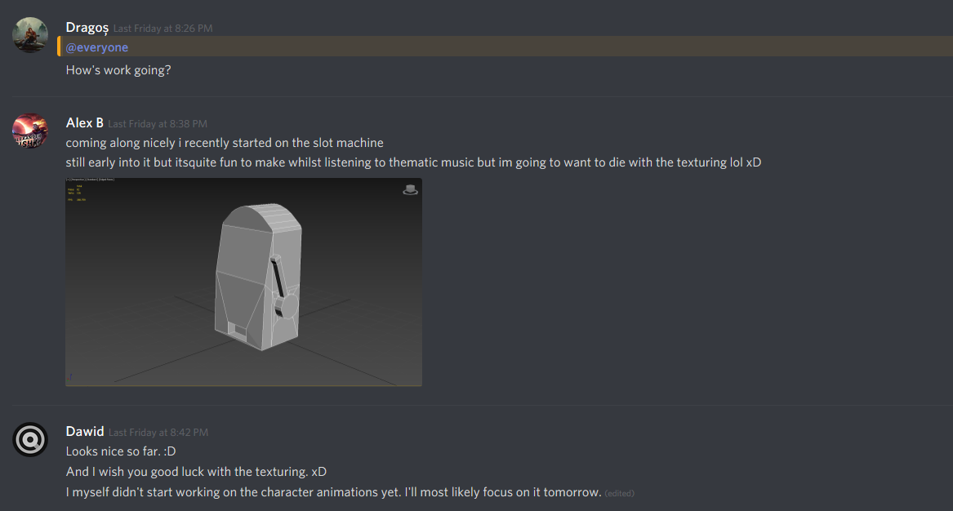 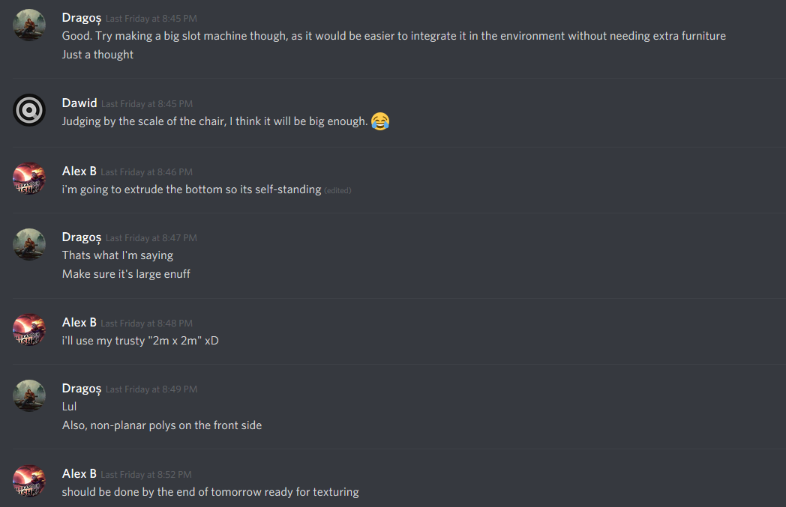 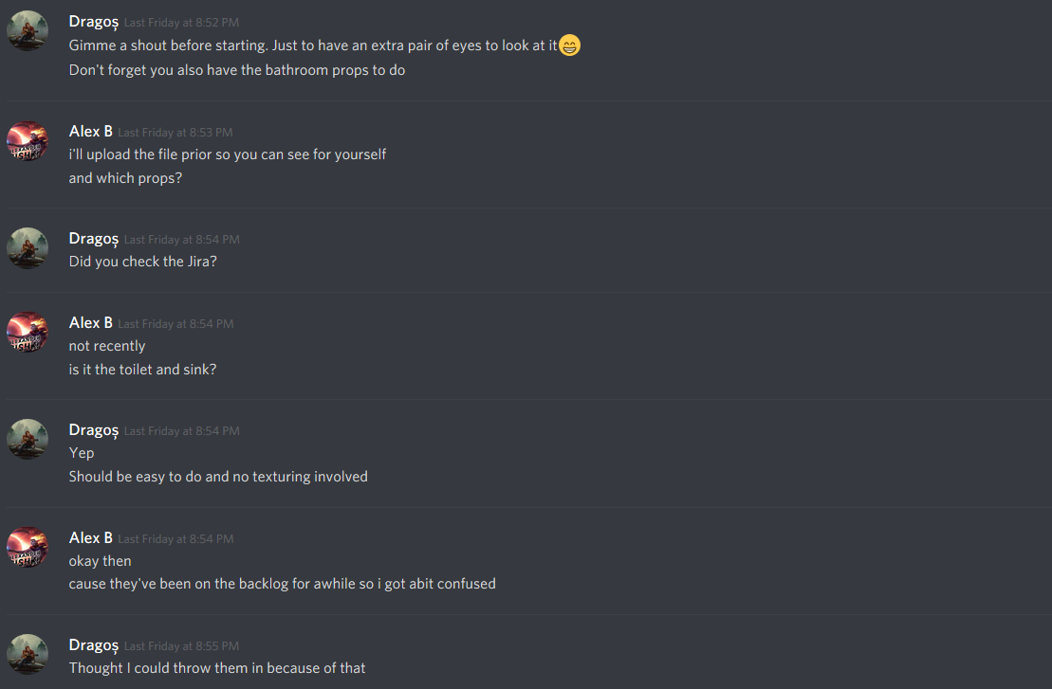 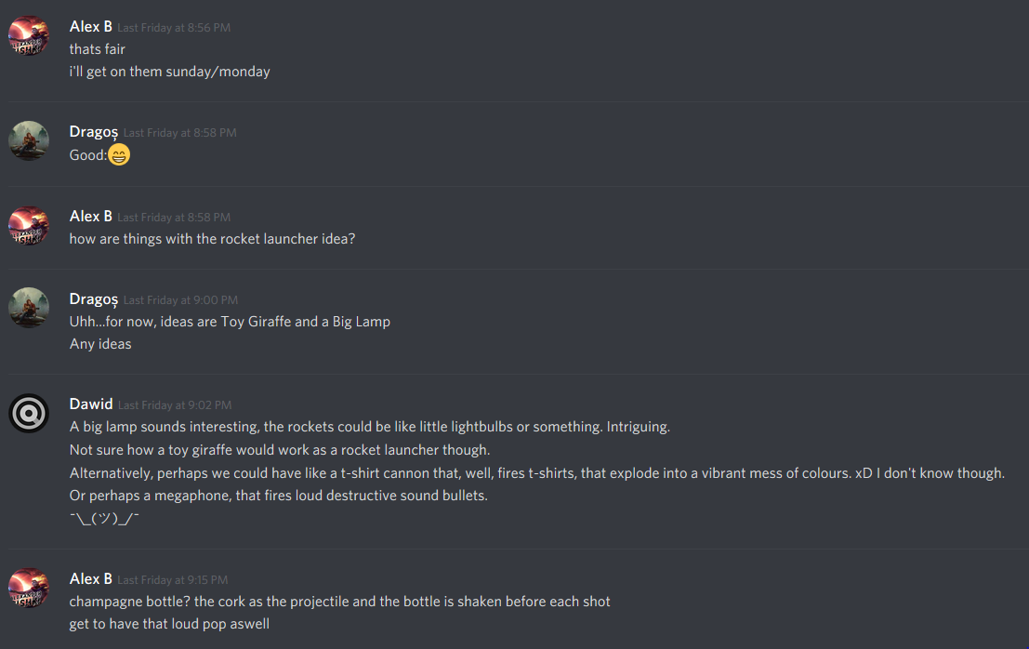 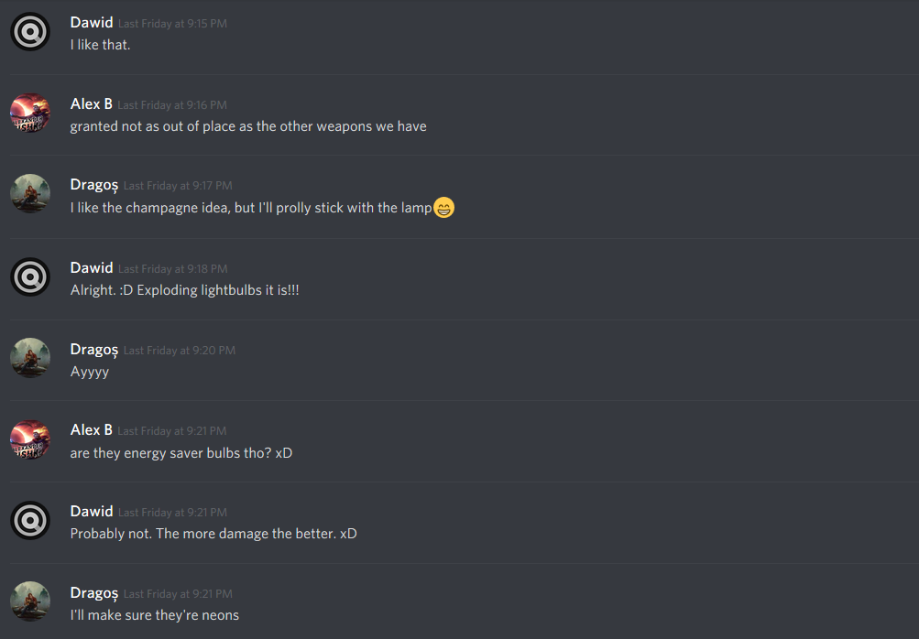

Screenshots 1 – 5 – A discussion about the work we have completed so far.

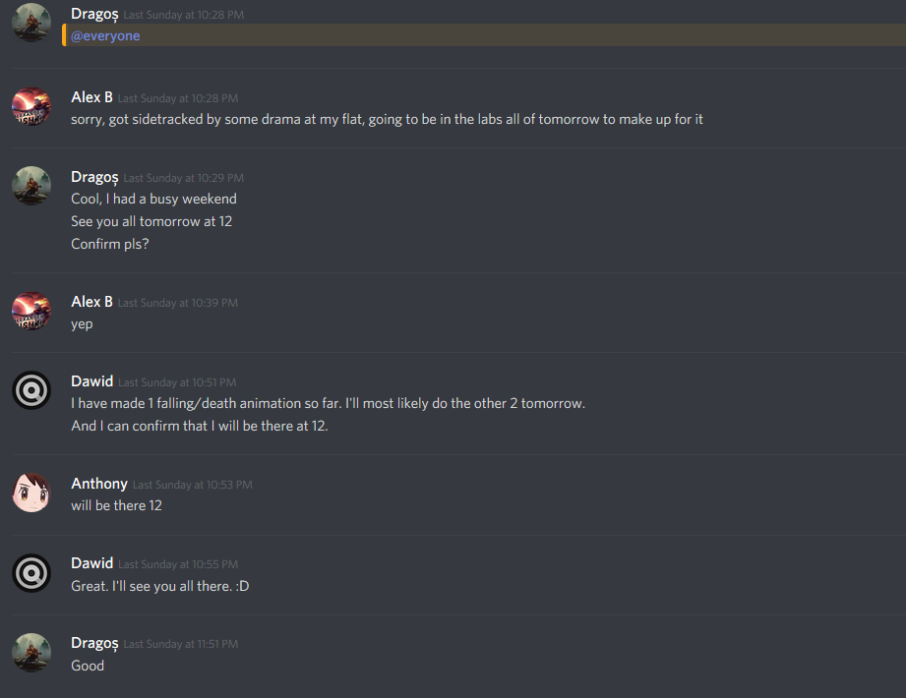

Screenshot 6 – Arranging the meeting for Monday for a mid-sprint review.

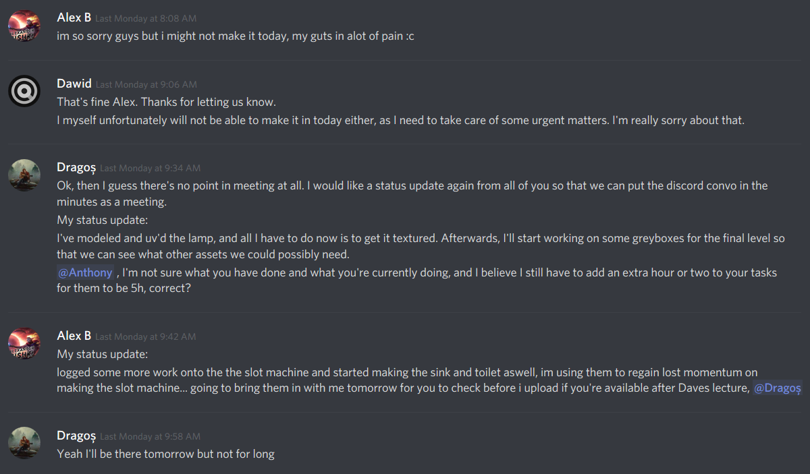 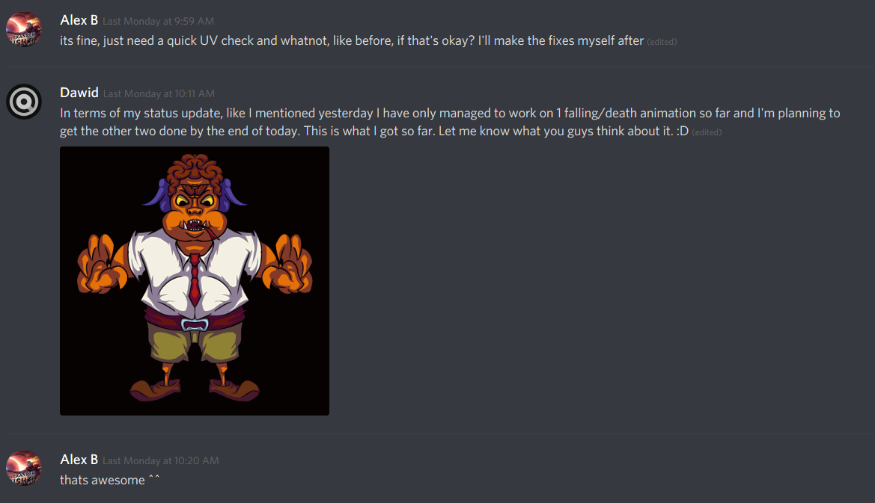 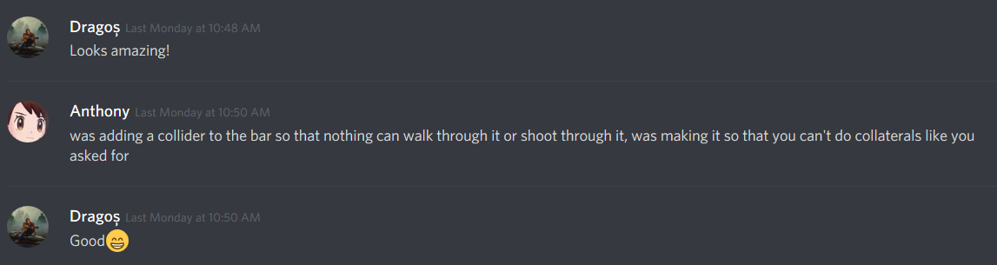

Screenshots 7 - 9 – Neither Dawid or Alex could make it to the meeting, so it was cancelled, and instead we decided we would discuss how the tasks are progressing.

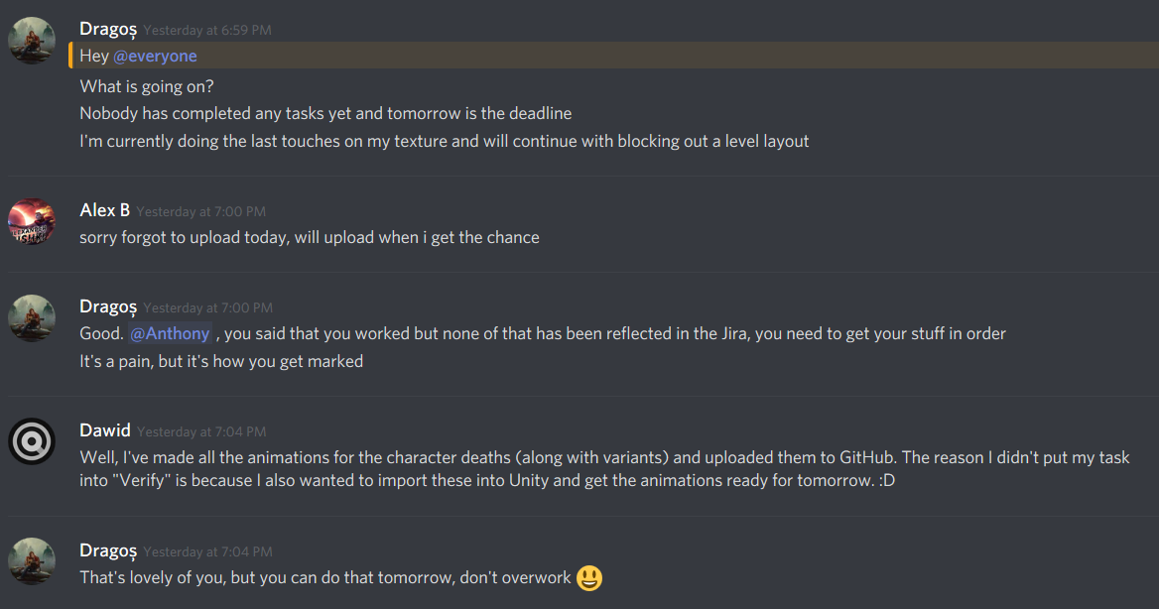 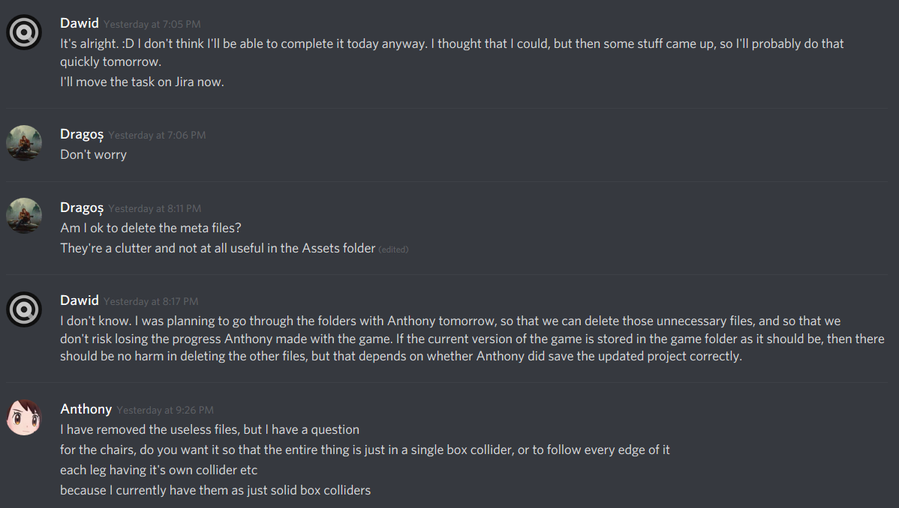 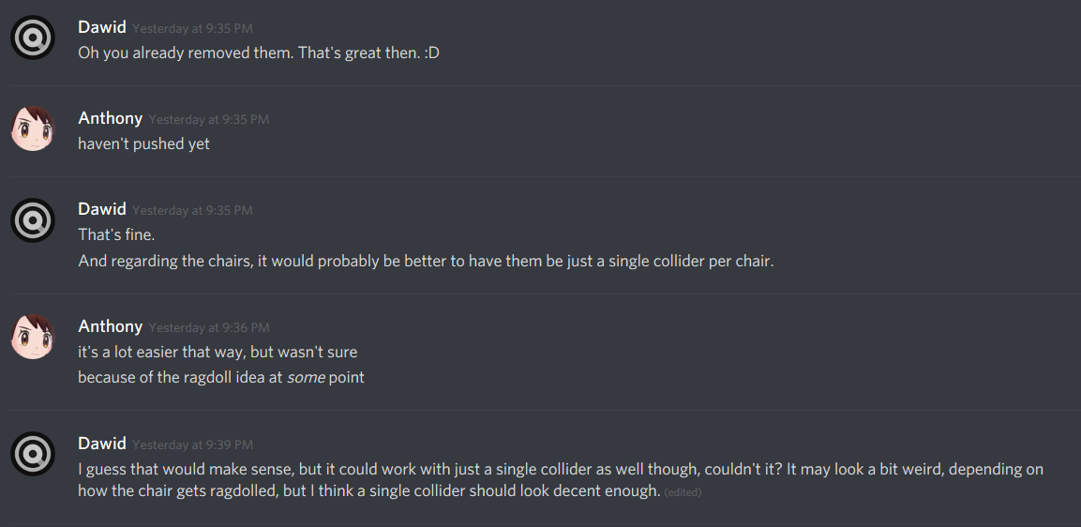 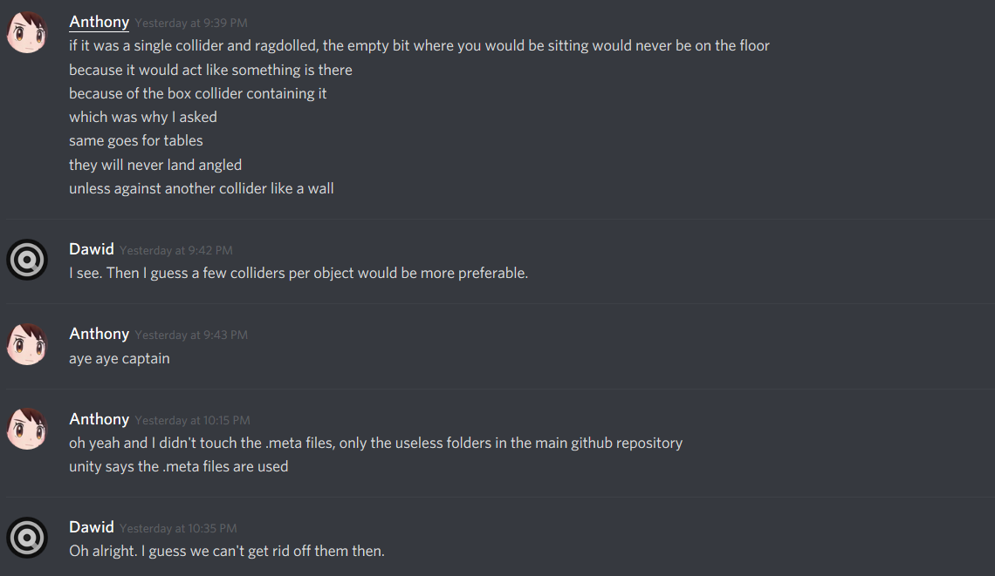 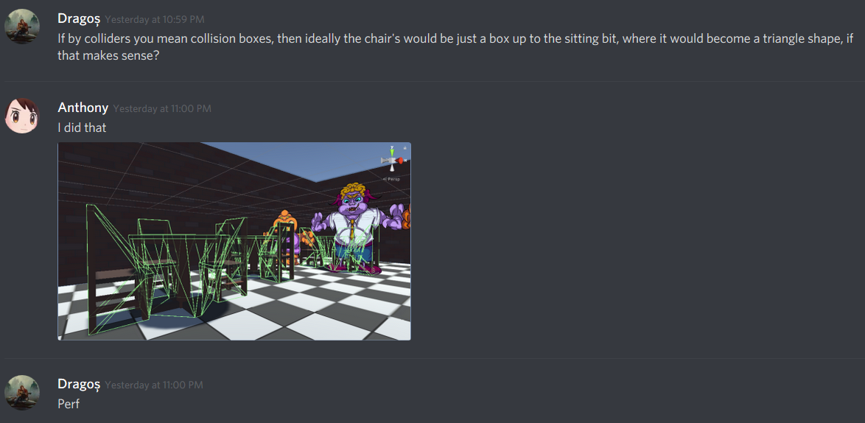 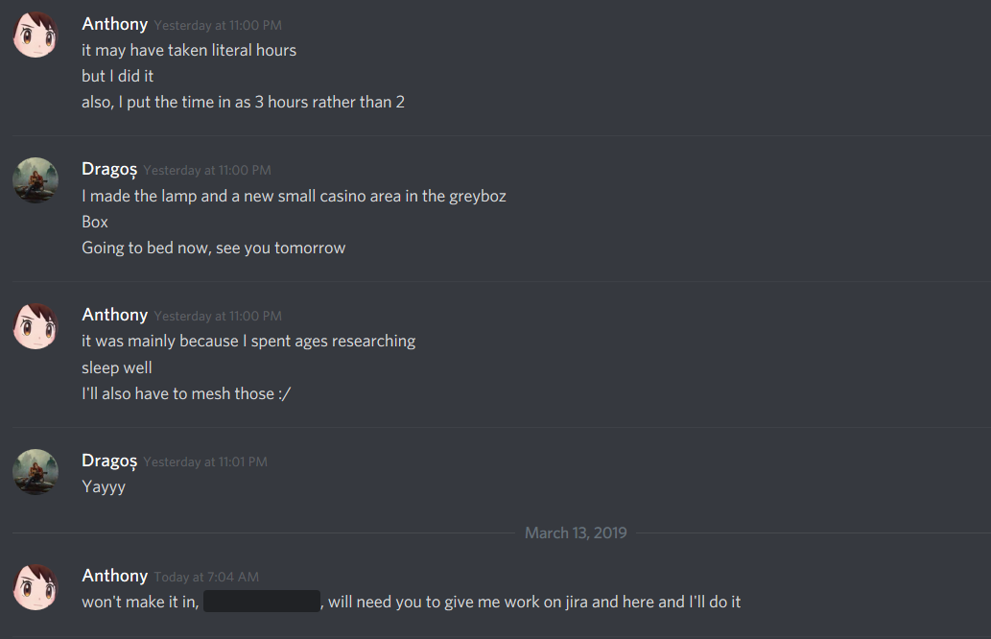

Screenshots 10 - 15 – Since there was no JIRA movement until late Tuesday, Dragos asked about how are the tasks progressing.

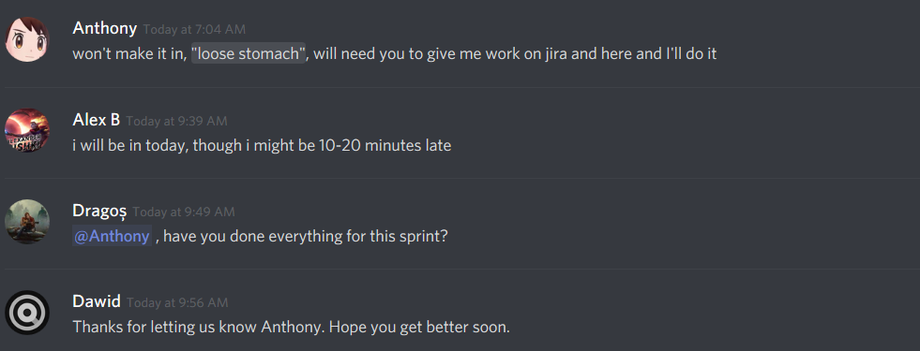

Screenshots 16 – Anthony letting us know that he won’t be able to make it to today’s meeting and session, and Alex letting us know he might be late 10 – 20 minutes..

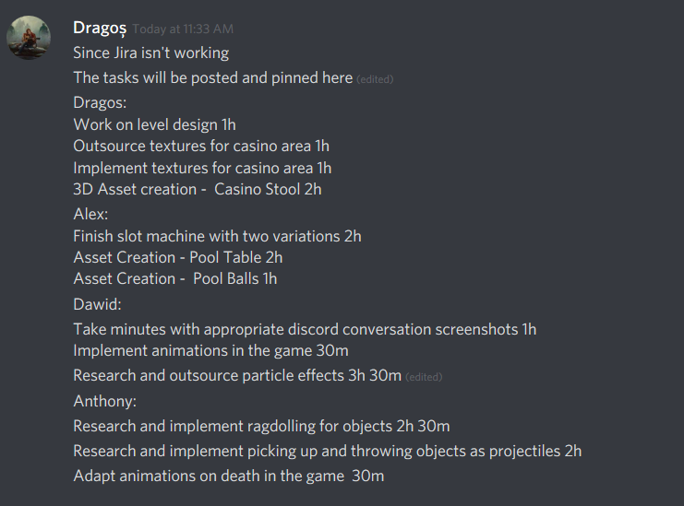

Screenshot 17 – Since JIRA wasn’t working Dragos took some time after the meeting to write down the list of tasks for this upcoming sprint, and that will be added into JIRA whenever it can be accessed.